
RUGBY COURSES TO BE HELD AT BOURNEMOUTH UNIVERSITY SPORTS GROUND.
HOME OF BOURNEMOUTH RUGBY CLUB
Chapel Gate, East Parley, Christchurch BH23 6BL

- Tues 10th Nov – Non-Contact Rugby for Schools Course
- Tues 17th Nov – Contact Rugby for Schools Course

Both courses are scheduled to run 1200-1500.

As part of the new programme, candidates must complete the mandatory online e-learning module before attending the practical face-to-face session. Successful completion of the online learning is a prerequisite for booking onto the practical component, so candidates will not be able to register for an in-person session until the digital element has been completed.
It's also important to note that the new course structure does not accommodate walk-ins or last-minute substitute attendees. All candidates must be registered in advance and have completed the required online learning before attending the practical session.

The following information tells you how to register , complete the online module . Only then can you apply to attend the face-to-face course.

ENGLAND RUGBY LEARNING – GUIDE FOR SCHOOLS

Registering for England Rugby Learning

How to book onto a course
England Rugby Learning - Step By Step Guide
- Visit https://englandrugbylearning.csod.com via a browser
- Create an account or register using your RFU Game Management System (GMS) Login details if you’ve previously logged into GMS (to find these details visit https://help.rfu.com/support/home)
- Select your personal preferences/coaching environment – you can choose ‘Teacher NonContact’ or ‘Teacher Contact’ or both
- Download the England Rugby Learning App
- Sign in using your Login details
- Based on the preferences you have selected, the system will promote/suggest courses that are applicable to your role. Alternatively, use the Search facility and enter “Schools”
- From the search results select the course you want (either ‘Contact’ or ‘Non-Contact’) and select ‘Request’
- Complete the online module. Once you have completed this you will then be able to select a face-to-face session from the courses available
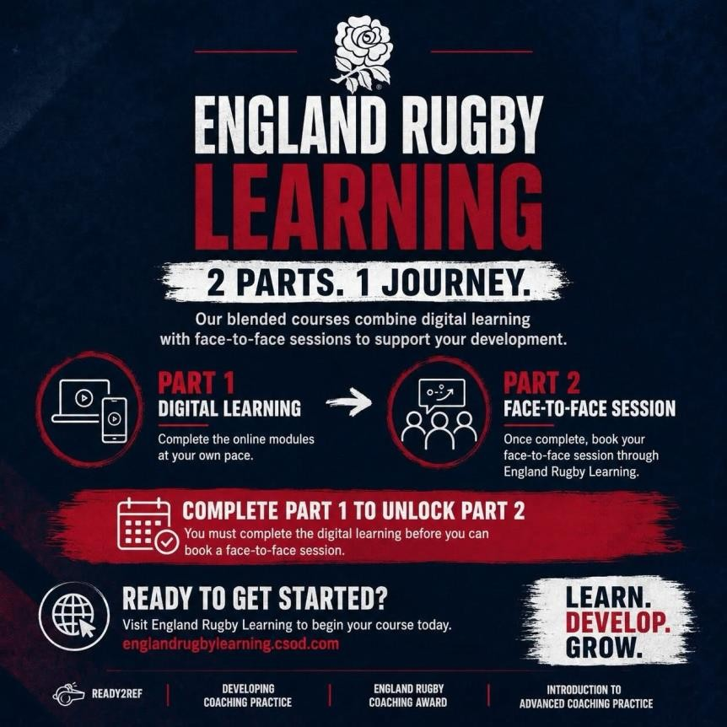
Find out more about our new learning platform England Rugby Learning
